**PROJECT REPORT**

**1. INTRODUCTION**

**1.1 Overview**

**Customize your resume for each job by including keywords from the job description to make it more relevant. Create a skills section - Highlight your skills and abilities relevant to the job you're applying for. List your education - Include your degrees, schools attended, and relevant course work.**

**1.2 Purpose**

**A resume is to give your potential employer a feel for past experience and skills. Remember you are trying to sell yourself, so emphasize your strengths. Most employers look for a steady job history and positive patterns of progression**

**2. PROBLEM DEFINITION**

**2.1 Empathy Map**

[**..\..\..\..\..\..\..\Documents\empathy map.pdf**](../../../../../../../Documents/empathy%20map.pdf)

**2.2 Ideation & Brainstorming Map**

**..** [**..\..\..\..\..\..\..\Documents\brainstromming map.pdf**](../../../../../../../Documents/brainstromming%20map.pdf)

**3. RESULT**

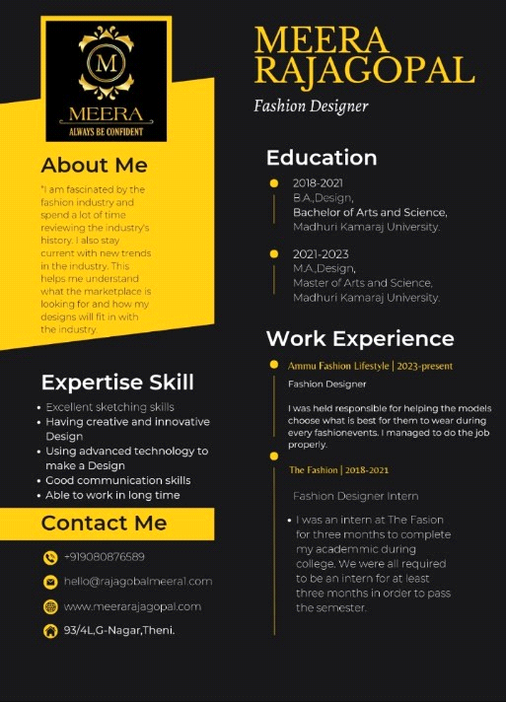

**4. ADVANTAGES & DISADVANTAGES**

* **Noun-based resume works for some industries (e.g., computer science)**
* **Highlights specific Knowledge**
* **Good for highlighting relevant experience that is not most recent job**
* **Does not address work history**
* **Does not show results or how knowledge is used**
* **May confuse reader because of out of order presentation of job chronology**

**5. APPLICATION**

* **We use the CANVA application to design our**

**Resume /CV**

**6. CONCLUSION**

* **A Resume or a CV is always called as the face of the job seeker.**
* **Each and every element whether it is heading, career objective, educational background, work experience, achievement or References must contain only true and relevant information.**

**--------**